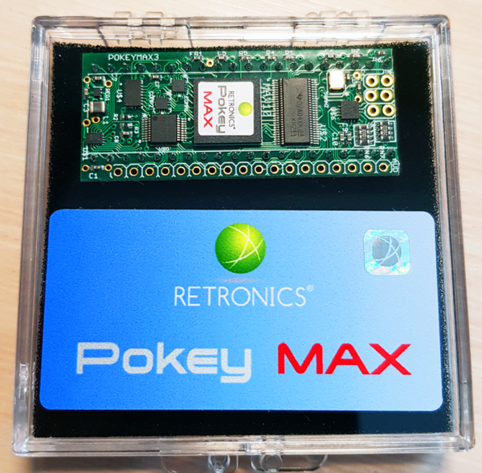
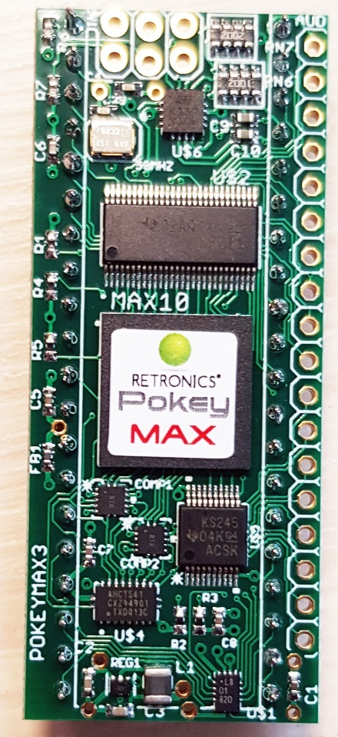
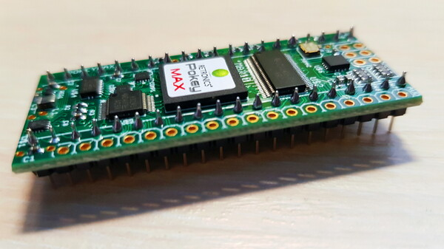
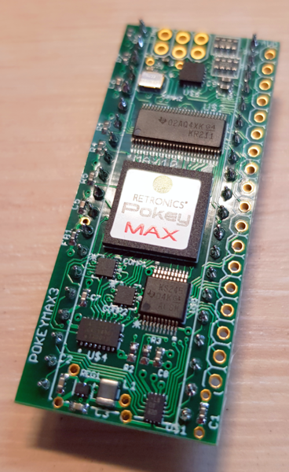
https://atariage.com/forums/upload s/monthly_2 021_04/PMv3_4.png.
Pokeymax V3
Infosammlung zum PokeyMax V3
Features:
- Quad Pokey
- Dual SID
- Dual PSG
- Four channel Covox, with Paula style DMA
- GTIA audio digital pass though
- SIO audio mixing
- PBI audio mixing
- Updated/configured via software on Atari
- Larger 10M16 FPGA, leaving adequate resources for future enhancements
- Spare 5V safe IO for future enhancements
- SPDIF digital output (TTL level, excludes SIO in/PBI in)
- PS2 keyboard input
- 21.5x52mm
- Special Firmware for 1088XEL
Software und Firmware gibt es hier: http://www.64kib.com/pokeymax_files/
Auf Atariage sind folgende Beiträge von Interesse:
https://atariage.com/forums/topic/316324-pokeymax-version-3-preorder/
https://atariage.com/forums/topic/295242-pokeymax-v2/
https://atariage.com/forums/topic/312360-problems-with-pokey-max-v2-no-covox/
Kontakt zu Duddie: jurek@retronics.eu
The design for v3 is from the start intended to fulfil the requirement, so will be offered as a single version, it has Pokey x 4, Sid x 2, PSG x 2 and Sample/Covox. There is a register to unmap the different the sound chip from memory. (PokeyCFG)
1088XEL needs a special Firmware: The special firmware is for the chip select handling. In the XEL it has a built in pokey upgrade, which looks at A5 and changes CS1 on the pokey sockets appropriately. This is no good for pokeymax since it'd only be active for the first pokey. So the firmware change ignores CS1. It also uses pin 37 of pokey socket 1 and 2 for stereo audio out. So the idea is to put pokeymax into slot one, then wire the AUD2 R to the plot socket 2 pin 37.
U1MB: There is a pokeymax plugin which communicates via the data bus. No wiring is needed.
GTIA audio output: connect EXT5 (Pin12) to pin 15 of GTIA - C014889 chip.
Stereo/mono switching:
Pokeymax has three features for this.

- It detects when the right channel is silent for a short period and automatically plays the left channel to both channels.
- It detects if A4 is connected or not (on power on). When not connected it goes into a basic mono mode.
- 'Chips' may be disabled in software using the 'RESTRICT' register. This is the feature that the U1MB plugin uses.

TK-II PS2: Falls PokeyMax und eine TK-II Erweiterung eingebaut wurde, sollte auf dem TK-II Fimware 2.7j und auf dem Pokeymax mindestens 1.23 installiert sein.
Covox address:
This is fixed at 0xD280. 0xD600 is possible with a wire connection to 74138 (Pin 9)

you can quickly test your COVOX with "XL Digital" music disk:
http://mono.i-demo.pl/xl_digital/xl_digital.atr
Boot this disk, then load XLDIGIT.COM by L option. On main menu use TAB key to setup COVOX address to $D280 then press 0 - all tunes will be played one by one.

Other disks with Pinokio's songs are:
http://mono.i-demo.pl/xl_digital/x16_tons.atr
http://mono.i-demo.pl/xl_digital/fort.atr
http://mono.i-demo.pl/xl_digital/xl_digital_play.atr
Load .XEX file with depressed SHIFT key, then configure COVOX address by arrow keys and accept your choice by RETURN. Song will be loaded and played.

Device orientation:
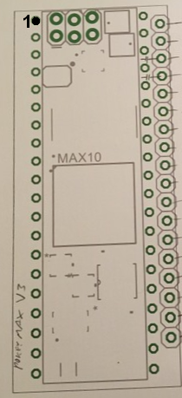

some players and Demos here:
http://www.64kib.com/pokeymax_files/software/players/
http://www.64kib.com/pokeymax_files/software/demos/

Also some example software here
http://www.64kib.com/pokeymax_files/software/examples/

+ sid wave test example
+ psg wave test example

AudIn 1+2: In the pokeymax there is a mixer which mixes the digital audio output and two analog inputs. The two analog inputs are mixed to both left and right outputs.
What it is for: Allowing hearing SIO 'interference' noise on the external audio outputs ('tch tch tch' when sio beeping is turned off). Allowing hearing SIO tape sound tracks. Allowing hearing misc PBI audio devices. Ground one of them, connect the other to the SIO audio in pin via a 1uF capacitor (optional, but may prevent issues with dc bias on some sio devices).

Adjusting the volume of the 'silent' beeps:
pin 3 sio --- 490K ohm --- pokeymax audin1 --- 10k ohm --- gnd
pin 11 sio --- pokeymax audin2

One bonus of this setup: You'll get the sio interference on devices without an SIO cable, such as FujiNet!

If Sound is overdriven, check this:
By default the channel divider were intended to be set as:
1 (internal): 2
2 (XEL) : 2
3 (left out): 4
4 (right out): 4

Unfortunately we accidentally shipped some with channel 1 and 2 set to a divider of 1.
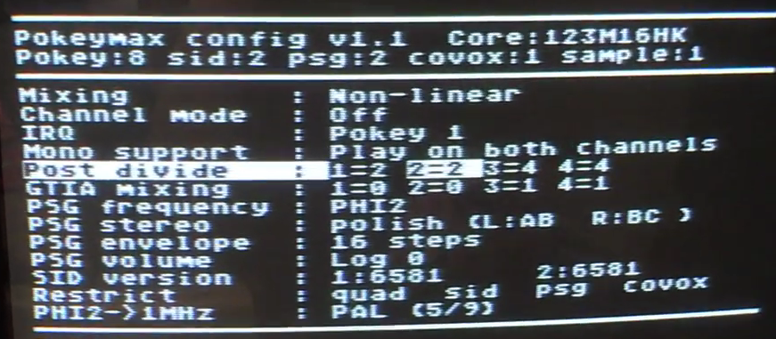
Einige Einstellungsmöglichkeiten der PoekyCFG Programmes werden in diesem Video erklärt: https://youtu.be/qcTuH0_iOPk
There is not enough room on the 10M02 FPGA variant for the flash controller. So, the settings can only be changed until reboot. If you want to change the settings then you will need run an xex on boot prior to running the software you want.

Infos zum Firmwareupgrade mit PokeyCFG:
Firstly I'd use the latest version from my site, which I see you found now. I put this and the cores here: http://www.64kib.com/pokeymax_files/.
Particularly important to make sure the software is new for updating the core, some earlier versions had some bugs for some configurations.

The larger FPGAs have flash storage (10M04/10M08/10M16), the small ones do not (10M02). The MXX is shown in the version code in pokeycfg. A quad+covox is definitely large enough, since it doesn't fit in the 10M02. For new ones @Duddie now started using 10M04 and higher.

When you "apply" the settings are activated until the next boot. When you "store" it writes the flash. Note that it does not activate it immediately. Pokeymax only reads its flash memory after a cold reboot. If you have a pokeymax without flash support then it does not have the "store" option. When you start up pokeycfg it reads the state from the registers on pokeymax, so if you have not rebooted after a "store" then you will indeed see the old settings.

"Restrict" removes chips from the memory map, so instead you will see mirrors of pokey1. Its just for incompatible software of if you don't want, for some user specified reason, to have a sid for example. I added it for the U1MB plugin so it was easy to disable devices to run incompatible software.
Das core.bin File muss auf einer Diskette in D4: abgelegt sein und sowohl zum FPGA Chip (M04, M08 oder M16) wie auch zur Version (SA, SQ … HK) passen. Für V3 gibt es nur eine M16 Version (außer für V3 unter 1088XEL)
Flash support was added to the core in 1.14 (10M08) and 1.15 (10M04).
After the update process all channels were silent due to the new feature that each pokey channel can be silenced seperately and therefore all channels were silenced on default but that took just a few seconds to change with pokeycfg so not a real showstopper.
When flashing with core.bin it does not overwrite the config, which has this (unfortunate) side effect when adding new settings.
Flashing 10M02 needs the use of a USB blaster, which can be bought fairly cheaper then building a special cable.
Retronics prefers that we keep JTAG updating via .pof to a select few hardware upgrade experienced members. e.g. @Duddie, @tf_hh and @flashjazzcat.
So at present upgrading is possible via two methods:
- pokeycfg.xex and core.bin. This does not require a JTAG adaptor, just an sio device with enough space. It does require a recent enough core to begin with for the in-system flash support. It is also only possible on larger devices with space of the in-system flash. i.e. 10M04,10M08 and 10M16. The files for this method are on my site.
- Send the board to one of the approved repairers for an upgrade, after checking with them for their charges etc.

Sollte beim Upgrade ezwas schief gehen, AUF KEINEN FALL den Rechner ausschalten. Einfach nochmal versuchen. Wenn alles nichts hilft, geht nur nochUpgrade über Blaster.
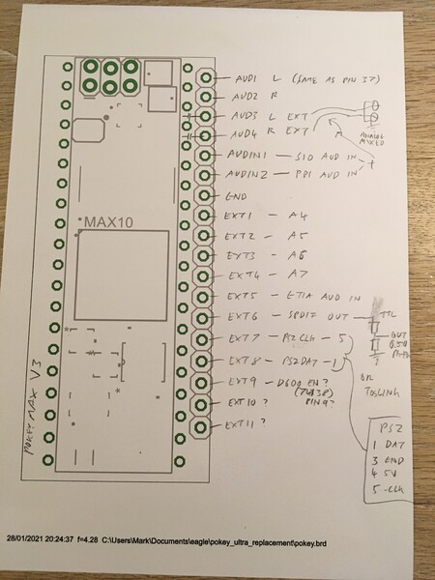
Ignore the EXT9 connection, this is not implemented. Currently EXT9,10,11 are unused.
Note that audin1/2 are dc coupled. In many Atari systems pbi audio in and sio audio in are internally connected. So it’s possible to pick up from there (after the ac coupling cap) and then ground the other input. With nothing connected it will run as a mono pokey.

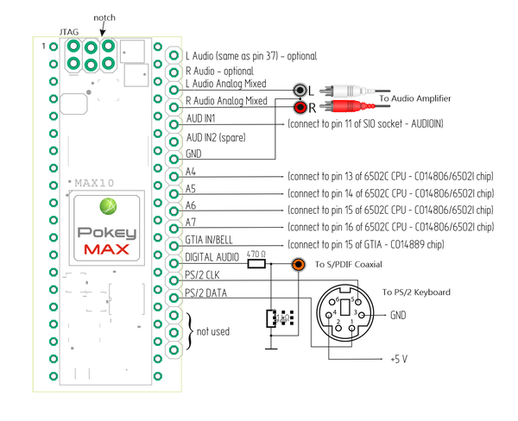
The PM V2 document showed two 10 uF caps in line of L-Audio Analog and R-Audio Analog. These caps are now installed on the PCB. This is also true for recent revisions of Pokeymax v2. V2B and V3 have caps on board.
S/PDIF and PS/2 parts can be skipped - they are optional. AUD IN1 and GTIA IN/BELL also are optional. PokeyMAX requires only proper connection to A4-A7 to work properly.
Falls nur reines Stereo gewünscht wird, dann A5-A7 auf Masse legen.
ACHTUNG bei Einbau in 600XL:
http://www.64kib.com/pokeymax_files/pokeymax_600xl_improvement.pdf
C89 und C90 (SIO_DATAin und SIO_DATAout) entfernen und je einen 100 Ohm Widerstand vor SIO-Stecker Pin 3 und 5.

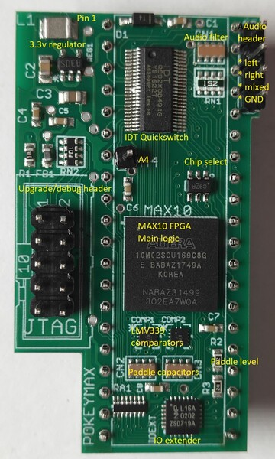
PokeyMax V1
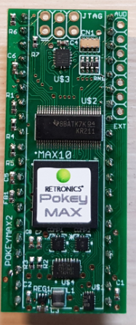
PokeyMax V2
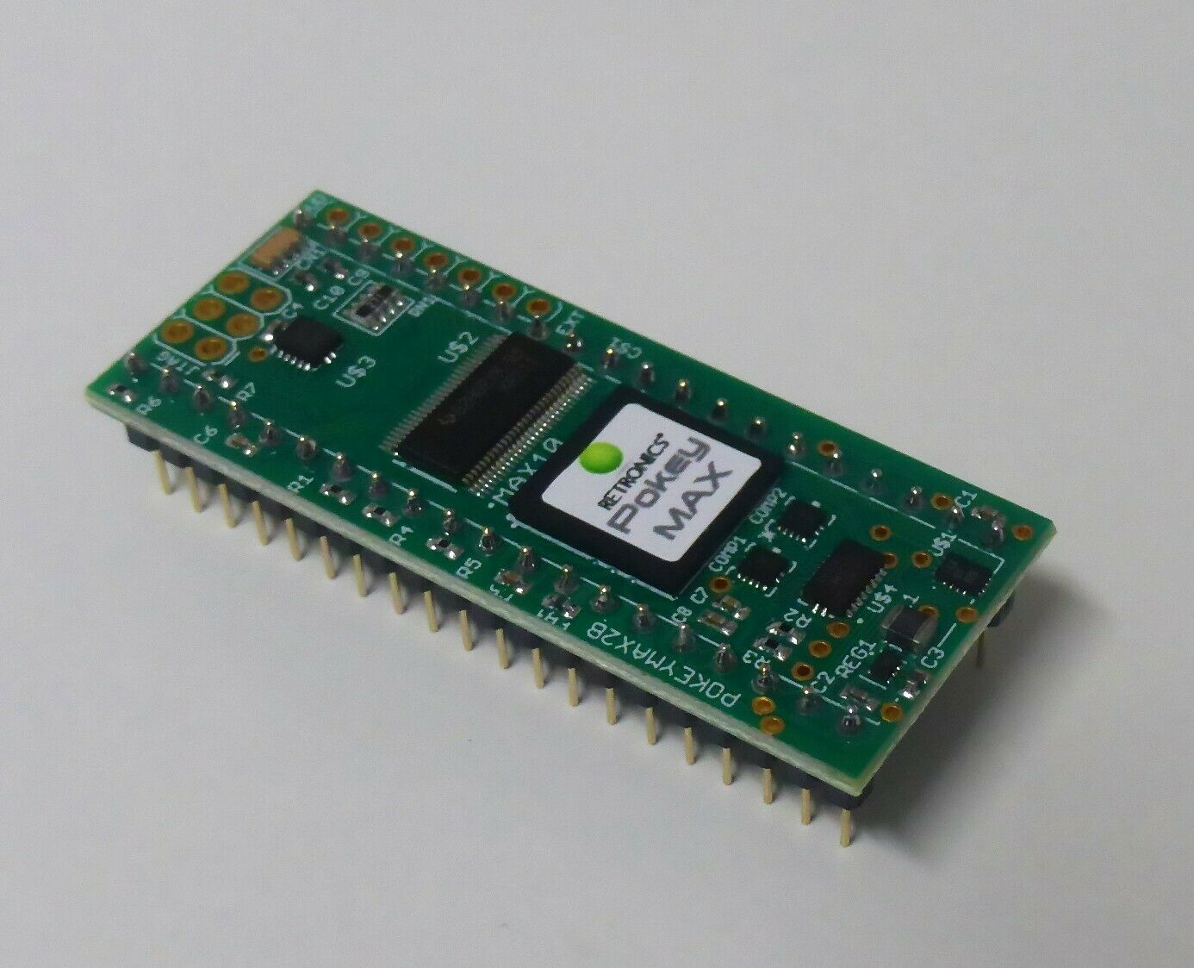
PokeyMax V2b
A quick summary of the versions! Essentially there are only 3 FPGAs currently shipping. 02,04 and 08. Then there are a selection of cores (Retronics sells them by core) which can fit on any FPGA big enough, though technically as long as the FPGA has enough space it can fit any core.

FGPAs Logic elements Block ram Usable flash Cost USD
10M02 2304 12 N* 7.11
10M04 4032 21 Y 9.63
10M08 8064 42 Y 11.16
10M16 15840 61 Y 27.36
*Flash controller takes 50% of space! Settings are volatile without flash

Code Name Pokeys PSGs SIDs Covox Sample U1MB GTIA CS1 Logic-Elem.
Code Switch in disabled (Approx)
MO Mono 1 0 0 0 0 N Y N 1500
SA Stereo 2 0 0 0 0 N Y N 2000
SU Stereo U1MB 2 0 0 0 0 Y Y N 2000
SX Stereo XEL 2 0 0 0 0 N Y Y 2000
SC Stereo Covox 2 0 0 1 0 N Y N 2300
QA Quad 4 0 0 0 0 N Y N 3500
QC Quad covox 4 0 0 1 0 N N N 3600
QM Quad sample 4 0 0 1 1 N N N 4600
QS Quad sid 4 0 2 0 0 N N N 6600
QP Quad psg 4 2 0 1 1 N N N 5500
HK Private dev! 4 2 2 1 1 N N N 8000

Firmware History

Changes(1.25):
- Two tone timing fix recently discussed on atariage (suppress pulse on two reset cycle)
- Add per audio channel disable flag (user request)

Changes(1.24):
- Timing sdc constraint corrections
- Flash controller timing improvements
- Backported sid improvements from sidmax
  - Envelope timing matches 100%
  - Zero wave
- Mix some sio rxd noise into audio

1.23 changes:
Pokey:
Use schmit trigger input on SID and BCLK
Additional synchronizers on sio clock in and sio input data
Fix misalignment with enable signal issue on synchronous input
v3:
Add spdif output
Add ps2 keyboard input (iso keyboard only for now)
Use real clock oscillator
config:
Fix bug in init of pal/ntsc mode
Default to pal mode
Flash switched to wrapping mode (smaller)

1.22 changes:
Environment:
Upgraded to Quartus 20.1.1
IP:
Disabled wrapping burst mode on 10M08 flash access - it saves space but is non-functional! Issue raised with Intel.
Config tool (1.0):
Add some safety checks to the flashing tool
- Allow halting and restarting the process (press break)
- Check stdio error codes properly!
Skip 0xff values (faster)
'Secret key' (x!) to allow displaying some flash contents!

1.21 changes:
SID/PSG:
1MHz and 2MHz clock are generated using the C64 method.
- PAL: 5/9 PHI2
- NTSC: 4/7 PHI2
- 2MHz is 10/9 and 8/7
Previously the SID/PSG clock varied up to 0-10% by device since its using the internal oscillator (now the internal oscillator only leads to a jitter change, since it counts the phi2 length)
Config tool (0.9):
Add PAL/NTSC selection for these clock dividers

1.20 changes:
SID:
Wave and envelope timing verified/corrected vs 6581
- 0 when all disabled, not 1
- noise init fix
- noise enable delay 2 cycles
- pulse delay fix (asymmetric)
- envelope stall bug fixed
Fixed read of osc c register
Sample support (dc offset in 6581 amplitude modulation, dc offset in 8580 ext in if digifix enabled)
Filter
6581 f distortion
Corrected 6581 and 8580 phase differences
Attenuate band pass (iirc) on 6581
Common
GTIA mixer fix
Config tool
Added sid digifix support (select 6581,8580 or 8580Digi)

1.19 changes:
Platforms
PokeyMax v1 backport
Common
Stereo auto version code corrected to SA
Remove some whistling (different dac frequencies)
Keyboard scan
Works with TKII well enough, though will be further improved in future TKII firmware
Sample
Tested/fixes: Clipping, correct data nibble, irq
SID
Fixed corrupted Q values
Config tool
Much improved display refresh time
No need to press control for arrow keys
Fixed apply settings for 2nd flash location

1.18 changes:
SID
filter q in flash (6581 or 8580)
mixed waveforms in flash (6581 or 8580)
Pokey
Force break anded in (turbo tape fix)
Volume to flash (In large FPGAs)
Keyboard scan
Inversion corrected
Scan uses interrupts
Scan run off pokey timer
I2C clock run at 1.5MHz (over spec but stable until 3.5MHz)
TKii/AKI should work
PSG
volume to flash
Config
Can disable devices by a register
Flash control fairness fix

1.17 changes:
- Added sample player - Paula style with ADPCM (alpha test)
- PSG volume linear or log
- SID filter f in flash (6581 or 8580)
- Pokey non-linear curve improved

1.16 changes:
- 2nd order sigma delta dac excludes unstable top and bottom of range
- config tool update reads from the registers for the initial state
- right channel detection based on xor rather than 5 bits (covox 2 channel fix)

1.15 changes:
- Added flash support to M04 cores
- Added M04 support to flash program
- Flash program renamed to pokeycfg.xex

1.14 changes:
- Registers initialized from flash
- Flash access from the core
- Register to disable automatic mono detection
- Fix quad pokey mixer overflow bug
- Serial input 5 cycle clock delay (brings sio timing closer to pokey)

1.13 changes:
- Doubled clock rate of second order sigma delta
- Changed version type of some cores:
  - xel stereo(pokey) => M02SX
  - psg quad(pokey) covox => M08QP -> wire up like quad pokey with covox (A4,A5,A7)
  - sid quad(pokey) => M08QS -> wire up with A4,A5 and A6

1.12 changes:
- Second order sigma delta
- Improved pokey non-linear volume curve
- Channel playing detection (if R not playing, it plays L)
- xel stereo build (disables CS1)
- New SID core developer build
New PSG core developer build

1.11 changes:
- Implemented IRQ enable reg.

1.10 changes:
- covox left channel: channel 1 + channel 4
- covox right channel: channel 2 + channel 3
- covox volume halved
- Added quad with covox memory map.
- Added 4 channel covox.

